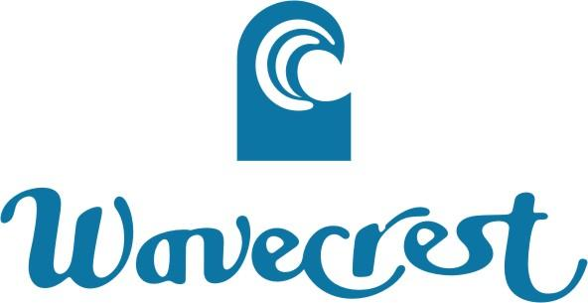

BOARD OF DIRECTORS - ASSOCIATION OF APARTMENT OWNERS
WAVECREST RESORT, INC.
Kaunakakai, Hawaii

Tuesday, March 14, 2017
9:00 a.m. HST
Wavecrest Cabana & via Teleconference

AGENDA

Call to Order: Determination of Quorum
Homeowner’s Roll Call
Proof of Notice of Meeting

Review/Approve: Regular Meeting Minutes of December 1, 2017

Officer’s Reports: President – Treasurer – Secretary – Resident Manager

Reports:
Sub-Metering – Jack
Shoreline Erosion – See Attachment
Reserve Fund Study – Martha and Jack

Old Business:
Exterior Wiring on Common Building Elements - Debbie
Update on List of Active Committees - Jack
Washers/Dryers - Jack

New Business:
The Resignation of Greg Crook from Board of Directors Acknowledged
The Censure of Board of Directors member Kris Chernik and Greg Crook Acknowledged
Acknowledgement that Bret Hoffman is no longer Manager - Michael
New Manager Search in Progress - Michael
Inactive Delinquent Owners - Martha

Open Session:
Owner’s Comments – Limited to 3 Minutes Each
Heating of Pool – Cathy Felkins

Executive Session:
Delinquencies and Liens – Employee/Personnel Issues – Legal Issues

Adjournment:
Teleconference Information:
1 (515) 603-3147
Guest Access Code 657819#
This is no longer a free call...........

